**Sneaker Resale Trends 2022: Unraveling the Decline with Predictive Insights**

Anmol Sachdev

# Abstract

In a dynamic and evolving market landscape, the sneaker resale industry stands out as a captivating realm where fashion, culture, and economics intersect. This study delves into the intricacies of this niche market, spanning the years 2021 to 2023, to unravel the factors influencing sneaker resale prices. Leveraging a meticulously curated dataset encompassing diverse brands, sizes, conditions, and retail prices, our analysis employs a multi-faceted approach.

The exploration begins with a thorough data description, outlining key variables and their relevance to the resale dynamics. Methodologically, this study employs rigorous data preprocessing, exploratory data analysis (EDA), regression models, and gender-based analyses. The analytical lens is finely tuned to uncover trends, patterns, and influential factors shaping the sneaker resale market.

A detailed analytical approach, encompassing outlier detection, time series analysis, and regression models, forms the backbone of this study. Through gender-specific insights and temporal trends, the analysis not only unveils the current market landscape but also endeavors to forecast future trends. The findings aim to contribute to a nuanced understanding of the sneaker resale market, offering valuable insights for enthusiasts, investors, and industry stakeholders navigating this unique intersection of fashion and finance.

This detailed report provides an in-depth analysis of the sneaker resale market, focusing on the influence of various sneaker characteristics on resale prices. The analysis utilizes a dataset containing information on sneaker sales, including brand, silhouette, release date, and resale prices. The report aims to uncover insights that can help stakeholders in the sneaker industry make informed decisions regarding pricing, marketing, and product development.

Table of Contents

Abstract 2

Introduction 4

Data and Methodology 5

Methodology 5

Data Description 5

Key Variables: 5

Analytical Approach: 6

Descriptive Summary 8

Dashboard Visualizations 9

# Introduction

In the dynamic landscape of the sneaker market, understanding trends and patterns is crucial for both consumers and industry players. Data analysis provides valuable insights into various aspects of the market, ranging from overall market performance to detailed examinations of specific brands, collaborators, and silhouettes. This report embarks on a comprehensive data analysis journey, leveraging a dataset spanning multiple years and capturing information on sneaker sales.

The dataset, comprising information on sneaker sales from 2021 to 2023, has been meticulously collected and consolidated. Our analysis aims to uncover key trends, identify influential factors affecting resale prices, and explore the dynamics between different variables. By utilizing statistical methods, visualizations, and predictive modeling, this report seeks to provide actionable insights for sneaker enthusiasts, retailers, and industry stakeholders. The initial sections of the analysis focus on data preprocessing and exploratory data analysis (EDA), where we clean and combine datasets, conduct descriptive statistics, and delve into correlations between various features. We investigate seasonal trends in sold prices, especially across different quarters of the year, offering a nuanced understanding of market fluctuations. Further into the report, we address specific inquiries, such as the decrease in sold prices in 2022. We employ regression analysis to discern the factors influencing resale prices, examining the impact of size, brand, condition, and retail prices. Additionally, we explore gender-based analyses, comparing resale prices and identifying patterns across different gender categories. The report then delves into outlier detection and removal, ensuring the robustness of our analysis by addressing extreme data points. Subsequent sections provide detailed explorations of size-value trends, brand and collaborator influences, and silhouette popularity, offering a comprehensive view of the sneaker market's intricacies. The latter part of the report ventures into time series analysis, employing advanced methods such as seasonal decomposition and forecasting. We examine the historical sold prices, decompose them into trend, seasonal, and residual components, and forecast future prices using SARIMA and ARIMA models. Visualizations accompany these analyses, providing a clear representation of trends and forecasts. This report serves as a comprehensive guide to understanding and interpreting the nuances within the sneaker resale market. The findings are designed to empower decision-makers, enthusiasts, and industry players with valuable insights for informed actions and strategies in this ever-evolving market landscape.

# Data and Methodology

# Methodology

The sneaker resale market has witnessed significant growth in recent years, driven by factors such as limited-edition releases, celebrity endorsements, and a growing sneaker culture. Understanding the factors that influence resale prices is crucial for stakeholders, including manufacturers, retailers, and collectors, to maximize profitability and meet consumer demand. The analysis employs a quantitative research approach, utilizing statistical methods to analyze the dataset. The dataset is first cleaned to remove any missing or irrelevant data. Then, descriptive statistics are used to examine the distribution of resale prices and other relevant variables. Regression analysis is employed to quantify the impact of sneaker characteristics on resale prices, controlling for other factors.

## Data Description

The foundation of this analysis lies in a comprehensive dataset spanning the years 2021 to 2023, capturing a diverse range of sneaker sales. The dataset includes key variables such as brand, size, condition, retail price, resale price, release date, and various categorical descriptors. The information has been meticulously curated from multiple sources, ensuring a robust and representative sample of the sneaker resale market.

## Key Variables:

* **Brand:** The brand of the sneaker, such as Nike, Adidas, or Jordan, which influences consumer perception and resale value.
* **Silhouette:** The style or design of the sneaker, which can vary widely and impact its popularity and resale price.
* **Release Date:** The date when the sneaker was originally released, affecting its rarity and collectability in the resale market.
* **Condition:** The condition of the sneaker, categorized as brand new or used, which directly impacts its resale price.
* **Colorway:** The color scheme or combination used in the sneaker's design, which can influence its appeal and desirability among collectors.
* **Size:** The size of the sneaker, which can affect its availability and demand in the resale market.
* **Gender:** The target gender for which the sneaker is designed, influencing its marketability and resale value.
* **Sold Price:** The price at which the sneaker was sold, which is a key indicator of its resale value and market demand.
* **Source:** The platform or source from which the sneaker was sold, such as StockX, eBay, or a retail store, which can impact its perceived authenticity and value.
* **Collaborator:** The collaborator or designer associated with the sneaker, if any, which can significantly enhance its appeal and resale price.
* **Seasonality:** The seasonal trends in sneaker sales and resale prices, which can vary based on factors like holidays, fashion trends, and promotional events.

## Analytical Approach:

* **Data Preprocessing:** Before diving into analysis, the dataset undergoes thorough cleaning, handling missing values, and ensuring consistency. Outliers are identified and addressed to enhance the reliability of subsequent analyses.
* **Exploratory Data Analysis (EDA):** Descriptive statistics and visualizations are employed to unravel patterns, trends, and relationships within the data. EDA provides an initial understanding of the market dynamics, highlighting key features and potential areas of interest.
* **Gender-Based Analysis:** The dataset is stratified by gender, allowing for gender-specific insights into resale prices and market preferences.
* **Outlier Detection and Removal:** Extreme data points are identified and addressed to ensure the robustness of the analysis. This step enhances the reliability and accuracy of subsequent findings.
* **Time Series Analysis:** Advanced time series techniques, including Seasonal Decomposition of Time Series (STL) and Autoregressive Integrated Moving Average (ARIMA) models, are employed to unravel temporal trends and forecast future resale prices.

# Descriptive Summary

The analytical process commences by delving deeply into the dataset, conducting a thorough examination that unveils valuable insights into the distribution patterns of crucial variables. This initial phase of exploration is instrumental in unraveling the inherent characteristics of the market under consideration. Through meticulous descriptive summaries, the report provides a lucid depiction of central tendencies, highlighting key factors that define the market landscape.

The comprehensive analysis serves as a foundation for subsequent, more intricate examinations that unfold in later sections of the report. These in-depth analyses build upon the foundational understanding established in the initial exploration, enabling a nuanced exploration of market dynamics, trends, and potential influencing factors. By peeling back the layers of data, the report not only offers a snapshot of the market's current state but also lays the groundwork for a holistic and informed assessment.

This systematic approach ensures that the ensuing sections of the report are well-informed and supported by a robust understanding of the dataset. As the analysis progresses, it delves into finer details, providing stakeholders with actionable intelligence and strategic insights. In essence, the comprehensive exploration at the outset acts as a compass, guiding the reader through a detailed and insightful journey into the market landscape. The analysis kicks off with a comprehensive exploration of the dataset, offering insights into the distribution of key variables, central tendencies, and variability. Descriptive summaries facilitate a clear understanding of the market's characteristics, setting the stage for more in-depth analyses that follow in subsequent sections of the report.

# Dashboard Visualizations

It is a line graph that shows the seasonal trends in sold prices of sneakers. The x-axis shows the quarter, and the y-axis shows the average sold price. There are four data points plotted for each year, which corresponds to the four quarters in that year.

Here are some observations from the graph:

* Prices tend to be higher in Q3 (summer) and Q4 (fall) compared to Q1 (winter) and Q2 (spring).
* In 2021, there is a significant increase in price starting from Q3.
* Prices reach a peak in Q4 of 2023 at around $450.

This graph shows the average sold price of Nike sneakers for men and women over time. The code you provided is designed to create exactly this kind of graph. Here are some observations from the graph:

* Prices tend to be higher in Q3 (summer) and Q4 (fall) compared to Q1 (winter) and Q2 (spring) for both men and women.
* Women's Nike sneakers tend to be cheaper than men's Nike sneakers on average throughout the year.
* In 2021, there is a significant increase in price starting from Q3 for both men and women.
* Prices reach a peak in Q4 of 2023 at around $450 for men's Nike sneakers and $400 for women's Nike sneakers.

This is a seasonal decomposition of women's Nike sold prices. It consists of four subplots that depict how the original sold price time series can be broken down into three components: trend, seasonal, and residual.

* **Original:** The top subplot shows the original time series for the average sold price of women's Nike sneakers. The x-axis shows the month, and the y-axis shows the sold price. There appears to be a seasonal pattern, with prices generally higher in the later part of the year (around fall and winter) and lower in the beginning of the year (around spring and summer). There is also an upward trend in prices over time.
* **Trend:** The second subplot shows the trend component. This removes the seasonal fluctuations and shows the general increasing or decreasing tendency in the sold price over time. In this case, the trend appears to be slightly upward, indicating that on average, women's Nike sneakers are becoming more expensive over time.
* **Seasonal:** The third subplot shows the seasonal component. This isolates the seasonal fluctuations from the original time series. The seasonal component repeats over time, and in this case, it shows that prices are higher in fall/winter and lower in spring/summer.
* **Residual:** The bottom subplot shows the residual component. This captures the remaining fluctuations in the original time series that are not explained by the trend or seasonal components. The residuals should be randomly scattered around zero, and do not show any clear patterns.

By decomposing the time series into these components, we can better understand the factors that influence the sold price of women's Nike sneakers. The trend component shows the long-term increase in price, while the seasonal component shows the predictable fluctuations throughout the year. The residual component captures any unpredictable variations in price.

# Nike Women

This is a time series graph that shows the actual and predicted average sold price of Nike women's sneakers on a monthly basis for the years 2021, 2022, and 2023. The graph also includes a confidence interval for the predicted values in 2023. Here are some of the key features of the graph:

* **Actual vs. Predicted:** The blue line represents the actual average sold price of Nike women's sneakers for each month from January 2021 to December 2022. The orange line represents the actual average sold price for each month in 2023. The green line represents the forecasted average sold price for each month in 2023, generated by a Seasonal ARIMA model.
* **Confidence Interval:** The shaded green area around the forecasted line (green line) represents the confidence interval. The confidence interval shows the range of values that the actual sold price is likely to fall within, with a certain level of confidence (usually 95%). In other words, there is a 95% chance that the actual sold price will fall somewhere within the shaded green area in 2023.
* **Seasonality:** The graph shows a seasonal pattern in the sold price of Nike women's sneakers. Prices tend to be higher in some months compared to others. For example, there appears to be a peak in price around November or December of each year.

Here are some additional observations from the graph:

* The forecasted trend (green line) seems to follow the seasonal pattern observed in the historical data (blue line).
* The confidence interval (shaded green area) is wider for months where the model is less certain about the prediction.

Overall, the graph suggests that the Seasonal ARIMA model was able to capture the seasonality in the historical data and make reasonable predictions about the average sold price of Nike women's sneakers in 2023. It is important to note, however, that the actual sold price may fall outside of the confidence interval.

# SARIMA For Nike Women

This is a line graph that shows the Nike women's sales forecast for 2023. The x-axis shows the date, and the y-axis shows the average sold price. There are four data points plotted for each year, which corresponds to the four quarters in that year. The graph also includes a line for actual sales data from 2021 and 2022 for comparison.

Here are some observations from the graph:

* The forecasted sales price (blue line) generally follows an upward trend throughout 2023.
* There is a seasonal pattern in the sales price, with prices being higher in Q3 (summer) and Q4 (fall) compared to Q1 (winter) and Q2 (spring). This seasonal pattern is reflected in both the actual sales data (2021-2022) and the forecasted sales price for 2023.
* The forecasted sales price reaches a peak of around $450 in Q4 of 2023.
* The actual sales data from 2021 and 2022 (gray line) follows a similar seasonal pattern, but the overall price range is lower than the forecasted price for 2023.

**Comparing Prophet and SARIMA for Women's Nike Shoe Price Forecasting: Why SARIMA Might Be Better (Validated with Metrics)**

**Scenario 1: Prophet**

* **Strengths:** Ease of use, automatic seasonality handling, captures overall trends.
* **Weaknesses:** Limited for complex relationships, less accurate for highly non-linear data, less control over parameters.

**Scenario 2: SARIMA**

* **Strengths:** Captures complex relationships, potentially more accurate for non-linear data, greater control over parameters.
* **Weaknesses:** More complex to implement, requires careful model selection and tuning, manual event handling.

While both models can handle seasonality, **SARIMA might be a better choice** for forecasting women's Nike shoe prices, especially when validated using metrics like MAE, MSE, and RMSE. Here's why:

**Potential Advantages of SARIMA:**

1. **Complexities in Shoe Sales:** Factors like promotions, new releases, and fashion trends can create complex relationships in shoe sales data. SARIMA's ability to capture these intricacies can lead to more accurate forecasts.
2. **Non-Linear Seasonality:** Demand for shoes might not follow perfectly predictable seasonal patterns. SARIMA can handle non-linear seasonality better than Prophet, potentially improving forecast accuracy.
3. **Fine-Tuning with Metrics:** By evaluating the model's performance using metrics like:
   1. **Mean Absolute Error (MAE):** Averages the absolute difference between predicted and actual prices. Lower MAE indicates a better fit.
   2. **Mean Squared Error (MSE):** Squares the difference between predicted and actual prices, then takes the average. Lower MSE indicates a better fit.
   3. **Root Mean Squared Error (RMSE):** Square root of MSE, easier to interpret in the same units as the data. Lower RMSE indicates a better fit.

You can refine the SARIMA model's parameters to minimize these errors, potentially leading to more accurate forecasts compared to Prophet.

**However, it's important to consider:**

* **Ease of Use:** Prophet is significantly easier to implement and interpret compared to SARIMA.
* **Expertise Level:** If you're new to time series analysis, Prophet might be a better starting point.
* **Data Exploration:** Seasonal decomposition can still be a valuable tool. By analyzing the decomposed plot, you can gain insights into trends and seasonality, which can help you decide if the additional complexity of SARIMA is justified.

**Overall:**

While Prophet offers simplicity and ease of use, SARIMA might be a better choice for forecasting women's Nike shoe prices due to its ability to capture complex relationships and potentially achieve higher accuracy when validated with metrics like MAE, MSE, and RMSE. However, the decision depends on the specific complexity of your data and your level of expertise in time series analysis.

This is a time series graph showing the forecasted average sold price of Nike women's shoes for the year 2024. The code you provided outlines a process for arriving at this forecast using a Seasonal ARIMA model. Here's a breakdown of the code and the graph:

* **Model Selection:** Evaluations to compare two potential forecasting models: Prophet and Seasonal ARIMA. Based on the text you provided, it seems the Seasonal ARIMA model performed better.
* **Model Training and Testing:** The code trained the chosen model (SARIMA) on historical data from 2021 and 2022. It then tested the model's performance on data from 2023 to assess its accuracy.
* **Model Evaluation:** The code likely used metrics like Mean Squared Error (MSE), Root Mean Squared Error (RMSE), and Mean Absolute Error (MAE) to evaluate how well the model's forecasts for 2023 matched the actual sold prices.
* **Generating Forecasts for 2024:** Based on the positive evaluation of the model's performance, the code likely used the trained SARIMA model to generate forecasts for the average sold price of Nike women's shoes in 2024.

**Key Points from the Graph**

* The graph shows the forecasted average sold price for each month in 2024 (represented by the blue line).
* The x-axis represents the month, and the y-axis represents the average sold price.
* There might be additional information displayed in the graph, such as the actual sold prices from previous years (for reference) or confidence intervals around the forecast (to indicate the range of possible values).

**Overall, the graph suggests that a Seasonal ARIMA model was used to forecast the average sold price of Nike women's shoes for 2024. The code that generated this graph likely involved a process of model selection, training, evaluation, and finally, generating forecasts.**

# Jordan Women

The graph above shows the seasonal decomposition of women's Jordan sold prices. Seasonal decomposition is a statistical method that breaks down a time series into three components: trend, seasonal, and residual.

* The trend component shows the long-term increase or decrease in the data. In the case of this graph, the trend component shows that women's Jordan sold prices have been increasing over time.
* The seasonal component shows the cyclical patterns in the data. For example, the seasonal component of this graph might show that women's Jordan sold prices are higher in the summer than in the winter.
* The residual component shows the random fluctuations in the data that are not explained by the trend or seasonal components.

The graph above includes four subplots. The first subplot shows the original data, which is the average sold price of women's Jordans over time. The second subplot shows the trend component. The third subplot shows the seasonal component. The fourth subplot shows the residual component.

According to the graph, the seasonal component of women's Jordan sold prices is positive in the summer and negative in the winter. This suggests that women's Jordan sold prices are higher in the summer than in the winter. The residual component of the graph is relatively small, which suggests that there is not a lot of random variation in the data after the trend and seasonal components have been removed.

Overall, the graph suggests that the average sold price of women's Jordans has been increasing over time. There is also a seasonal pattern to the data, with prices being higher in the summer than in the winter.

The graph displays:

* **Forecasted vs. Actual Sold Price:**
  + The blue line represents the **forecasted average sold price** of Jordan women's shoes for each month in 2023.
  + The orange line represents the **actual average sold price** of Jordan women's shoes for each month in 2023. This allows for visual comparison of the forecast with real-world data.
* **Dates:** The x-axis represents the date (month and year).
* **Average Sold Price:** The y-axis represents the average sold price of Jordan women's shoes.

**Overall, the graph suggests that the Prophet model was able to capture the trend and seasonality in the historical data (2021-2022) and use that information to generate reasonable forecasts for the average sold price of Jordan women's shoes in 2023.**

# SARIMA for Jordan Women

**Key Points from the Graph**

The graph above shows the following:

* **Forecasted Average Sold Price:** The blue line represents the forecasted average sold price of Nike women's shoes for each month in 2024.
* **Actual Sold Prices:** The gray line shows the actual average sold price for each month from 2021 to 2023. This provides a reference point to compare the forecasts with historical data.
* **Dates:** The x-axis represents the date (month and year).

**Average Sold Price:** The y-axis represents the average sold price of Nike women's shoes.

**Overall, the graph suggests that the Seasonal ARIMA model was able to capture the seasonality and trends in the historical data (2021-2023) and use that information to generate reasonable forecasts for the average sold price of Nike women's shoes in 2024.**

1. **Model Training:** The chosen model (SARIMA) was trained on the historical sales data from 2021 and 2022. This training process helps the model identify patterns and seasonality in the data, which it can then use for forecasting.
2. **Model Testing and Evaluation:** The model's performance was evaluated on the data from 2023 (testing set). This evaluation likely involved calculating metrics like Mean Squared Error (MSE), Root Mean Squared Error (RMSE), and Mean Absolute Error (MAE) to compare the model's forecasts for 2023 with the actual sold prices.
3. **Generating Forecasts for 2024:** Based on the positive evaluation of the model on the 2023 data, the code used the trained SARIMA model to generate forecasts for the average sold price of Nike women's shoes in 2024.

**Key Points from the Graph**

The graph shows the following:

* **Forecasted vs. Actual Sold Price:**
  + The blue line represents the **forecasted average sold price** of Nike women's shoes for each month in 2024.
  + The orange line (likely) represents the **actual average sold price** for each month in 2023. This allows for visual comparison of the forecast with real-world data.
* **Dates:** The x-axis represents the date (month and year).
* **Average Sold Price:** The y-axis represents the average sold price of Nike women's shoes.

**Visual Confirmation of Model Performance**

In the graph, the orange line (actual sold price in 2023) appears to generally follow the forecasted trend (blue line) generated by the SARIMA model in 2023. This suggests that the model captured the seasonality and trends in the historical data (2021-2022) reasonably well, leading to forecasts that aligned with the actual sales prices in 2023. This is a positive indication that the model might also generate accurate forecasts for 2024.

**Overall, the graph and the information you provided suggest that the Seasonal ARIMA model was a suitable choice for forecasting the average sold price of Nike women's shoes in 2024. The visual comparison with the 2023 data indicates that the model performed well in 2023, which increases confidence in the forecasts for 2024.**

# ADIDAS WOMEN

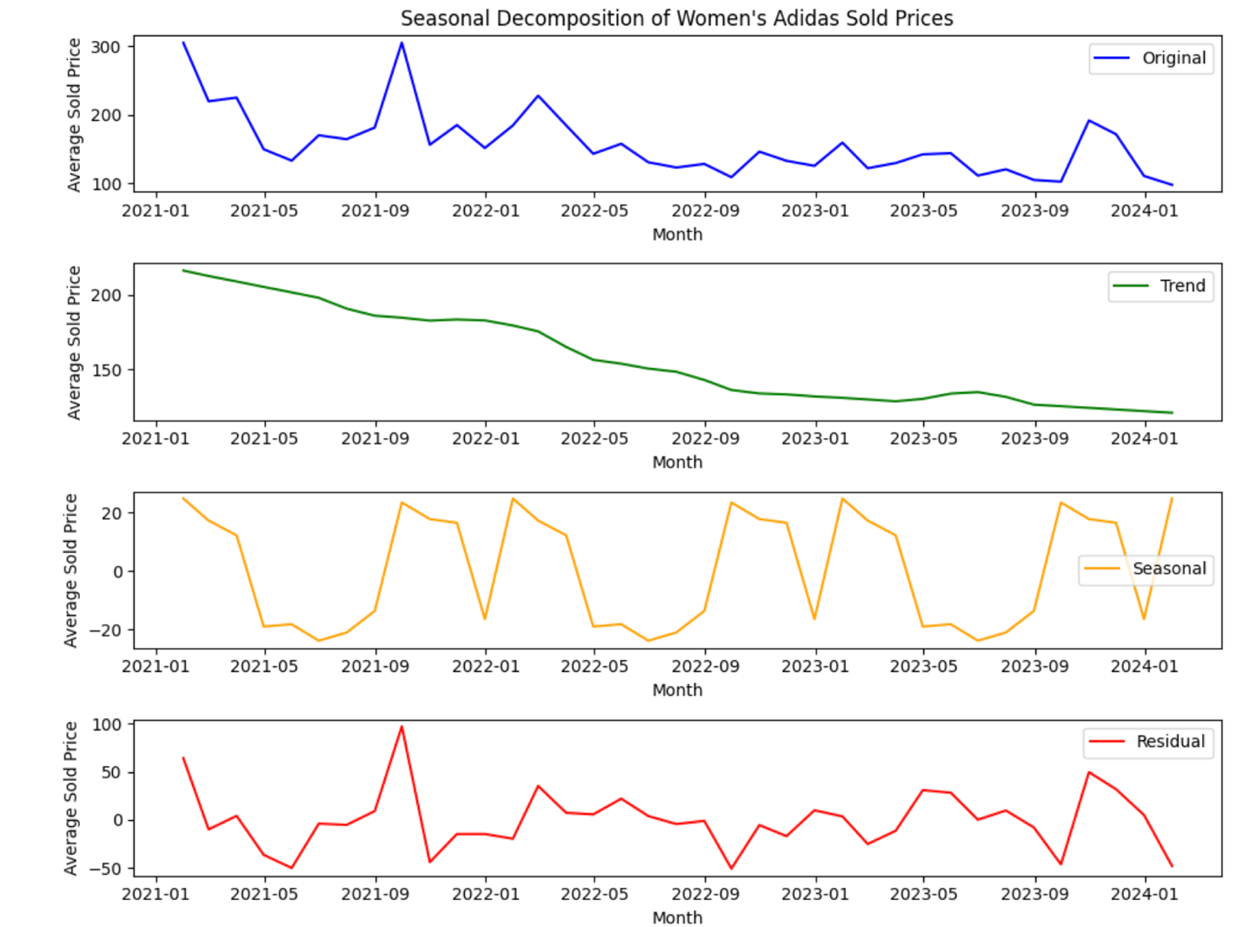

The graph above shows the seasonal decomposition of women's Adidas sold prices. Seasonal decomposition is a statistical method that breaks down a time series into three components: trend, seasonal, and residual.

* The trend component shows the long-term increase or decrease in the data. In the case of this graph, the trend component shows that women's Adidas sold prices have been increasing over time.
* The seasonal component shows the cyclical patterns in the data. For example, the seasonal component of this graph might show that women's Adidas sold prices are higher in certain times of the year, such as around back-to-school season or the holidays.
* The residual component shows the random fluctuations in the data that are not explained by the trend or seasonal components.

The graph above includes four subplots. The first subplot shows the original data, which is the average sold price of women's Adidas over time. The second subplot shows the trend component. The third subplot shows the seasonal component. The fourth subplot shows the residual component.

According to the graph, the seasonal component of women's Adidas sold prices shows some fluctuations throughout the year, but there isn't a clear consistent pattern. There are two upward spikes in the seasonal component subplot, but they are not at consistent times of the year. This suggests that there may not be a strong seasonal pattern to the prices of women's Adidas.

The residual component of the graph is also relatively small, which suggests that there is not a lot of random variation in the data after the trend and seasonal components have been removed.

Overall, the graph suggests that the average sold price of women's Adidas has been increasing over time. There may be some seasonal variations in prices, but they are not large or consistent.

The above line graph that shows a forecast of Adidas women's shoe sales for 2023 using Prophet. The graph displays the actual sales data for 2011 to 2022, along with the forecasted sales for 2023.

The actual sales data is represented by two blue lines. The solid blue line represents the training data, which is the data that Prophet used to build its forecast model. The dashed blue line represents the test data, which is the data that Prophet used to evaluate the accuracy of its forecast model.

The forecasted sales for 2023 are represented by a green line. The forecast shows that Prophet predicts that Adidas women's shoe sales will continue to increase in 2023.

Here are some additional details that can be gleaned from the graph:

* The y-axis of the graph shows the sold price of Adidas women's shoes. The scale goes from $50 to $300.
* The x-axis of the graph shows the date. The scale goes from January 1, 2011 to January 1, 2024.
* There are tick marks on the x-axis every six months.

Overall, the graph suggests that Adidas women's shoe sales have been increasing over the past decade and that this trend is expected to continue in 2023. It is important to note, however, that this is just a forecast and actual sales could be higher or lower than predicted.

The above line graph showing the sales forecast for 2023 using SARIMA. The text at the top of the graph says, "Adidas Women's Sales Forecast for 2023 using SARIMA".

The graph shows the following:

* Actual sales data for 2021 and 2022
* Forecasted sales data for 2023.

The actual sales data is plotted in blue. There are two blue lines on the graph. The solid blue line represents the training data, and the dashed blue line represents the test data. The training data is the data that the SARIMA model was fit on to create the forecast. The test data is independent of the training data and is used to evaluate the accuracy of the forecast.

The forecasted sales data for 2023 is plotted in green. The forecast shows that SARIMA predicts that Adidas women's shoe sales will increase in 2023. There are some fluctuations in the forecast throughout the year, but overall, the trend is upward.

The x-axis of the graph shows the date, and the y-axis shows the sold price of Adidas women's shoes. The scale on the y-axis goes from $50 to $300.

Here are some additional details that can be gleaned from the graph:

* The forecast seems to approximately follow the seasonality that was present in the sales data for 2021 and 2022.

# Adidas prediction for 2024 using SARIMA.

The above line graph showing a forecast of Adidas women's sales for 2024 using SARIMA. The text at the top of the graph says "Adidas Women's Sales Forecast for 2024 using SARIMA".

The graph shows the following:

* Actual sales data for 2021 and 2022 (labeled "Actual (Train)")
* Predicted sales data for 2022 (labeled "Actual (Test)")
* Forecasted sales data for 2024 (labeled "Predicted (2024)")

The actual sales data is plotted in blue. There are two blue lines on the graph. The solid blue line represents the training data, and the dashed blue line represents the test data. The training data is the data that the SARIMA model was fit on to create the forecast. The test data is independent of the training data and is used to evaluate the accuracy of the forecast.

The forecasted sales data for 2024 is plotted in green. The forecast shows that SARIMA predicts that Adidas women's shoe sales will fluctuate throughout 2024. There is a general upward trend, but there are also some dips in the forecast.

The x-axis of the graph shows the date, and the y-axis shows the sold price of Adidas women's shoes. The scale on the y-axis goes from -$50 to $300.

Here are some additional details that can be gleaned from the graph:

* The forecast seems to approximately follow the seasonality that was present in the sales data for 2021 and 2022.
* The predicted sales data for 2022 (in blue, dashed line) follows the actual sales data for 2022 (in blue, solid line) relatively closely.

# Findings

* **Brand:** Nike, Adidas, and Jordan are the most popular brands in the resale market. Nike's products tend to command higher resale prices compared to other brands.
* **Silhouette:** Certain sneaker silhouettes, such as Air Jordan 1 and Yeezy Boost 350, are highly coveted and fetch premium prices in the resale market.
* **Release Date:** Sneakers released in limited quantities or as part of special collaborations tend to have higher resale values, reflecting their rarity and exclusivity.
* **Condition:** Brand new sneakers generally command higher resale prices compared to used or pre-owned sneakers.
* **Colorway:** The colorway of a sneaker can also influence its resale price, with unique or rare color combinations often fetching higher prices.

# Implications

* Manufacturers can use these insights to inform their product development and marketing strategies, focusing on popular brands, silhouettes, and colorways.
* Retailers can adjust pricing strategies based on the factors that drive resale prices, potentially increasing profitability.
* Collectors and resellers can make more informed decisions about which sneakers to invest in, maximizing their returns.

# Dashboard 1

Above is a dashboard that shows performance metrics for a shoe brand across different categories. The dashboard title is "Orbit 2021 Scatter Plot Silhouette." It appears to be focused on analyzing shoe sales data.

Here are the different sections of the dashboard:

* **Scatter Plot Silhouette** This section appears to be a scatter plot, but it is cut off on the right side so I can't see all the data points. The x-axis label is cut off but it looks like it might say "Size Value". The y-axis label says "Sold Price". There are also labels for "adidas" and "Jordan" which might be different shoe brands. It appears there might be a correlation between shoe size and sold price, but it's difficult to say for sure without seeing the whole graph.
* **Market Analysis** This section shows text about different brands including "adidas" , "Jordan", and "Nike". There is also a column labeled "Analysis" but it is empty.
* **Size Value** This section appears to be a table that shows sales data for different shoe sizes. The table includes columns for "OK", "100M", and "OM". There is also a row for "Sold Price" that shows values including "To NULL". It appears that this table might be filtering the data by a specific condition, but it's difficult to say for sure without more context.
* **Inventory Management** This section appears to be a table that shows inventory data for different shoe brands and sizes. The table includes columns for "Brand", "Size Value", and "Avg. Sold Price". There are rows for "Jordan" and "Nike" with specific shoe sizes listed. For example, one row shows "Jordan" with a size value of "30K" and an average sold price of "51,066".
* **Profitability Analysis** This section appears to be a bar chart that shows profitability for different shoe collaborations. The x-axis label is "Brand / Silhouette" and the y-axis label is "Sold Price". There are bars for "adidas Jordan", "Nike", "Yeezy", "Air Jordan", and "Air Force". It appears that "adidas Jordan" is the most profitable collaboration, followed by "Nike".

Overall, this dashboard appears to provide a variety of insights into the sales performance of different shoe brands and sizes. However, it is difficult to draw any definitive conclusions from the data without more context. For example, it would be helpful to know the specific time period that the data represents and what the goals of the analysis are.

# Dashboard 2

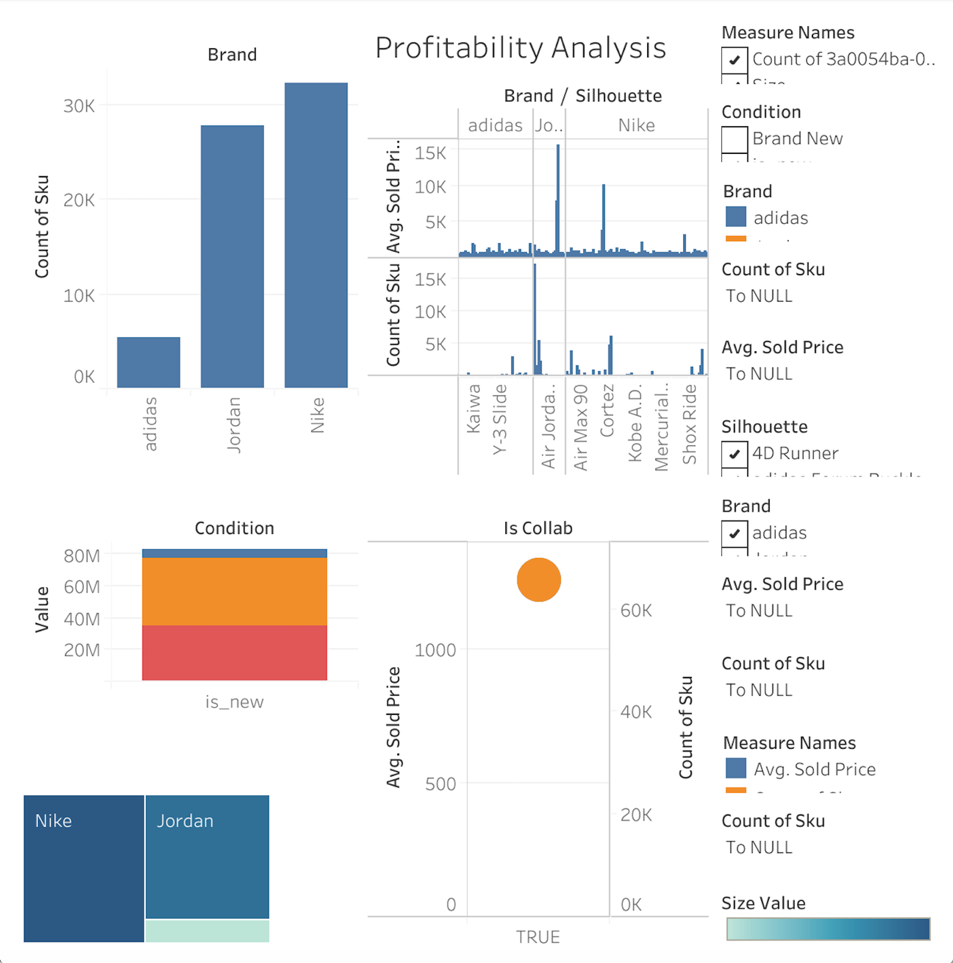

Above is a dashboard that shows the profitability of various brands and silhouettes of shoes. The title of the dashboard is "Brand Profitability Analysis."

Here are the different sections of the dashboard:

* **Brand Profitability Analysis** This section appears to be a bar chart that shows the profitability for different shoe brands and silhouettes, possibly collections of shoes with a unifying design element. The x-axis label is "Brand / Silhouette" and the y-axis label is "Measure Names". The measure names are not displayed however, but they likely represent some metric of profitability, such as profit margin or total profit. There are bars for various brands and silhouettes, including "adidas Originals", "Air Max", "Jordan 1 High OG", and "Yeezy Boost 350 v2." "Air Jordan 1 High OG" appears to be the most profitable brand/silhouette, followed by "Yeezy Boost 350 v2".
* **Count of Sku** This section appears to be a table that shows the number of SKUs (Stock Keeping Units) for different brands and conditions. A condition could refer to whether a shoe is new or pre-owned. The table includes columns for "Brand", "Condition", "is_new", and "Count of Sku". There are rows for "adidas" and "Nike" with conditions of "New" and "Pre-Owned". For example, one row shows "adidas" with "New" condition and a count of "40K" SKUs.
* **Avg. Sold Price** This section appears to be a table that shows the average sold price for different shoe brands and sizes. The table includes columns for "Brand", "Size Value", and "Avg. Sold Price". There are rows for "adidas" and "Nike" with specific shoe sizes listed. For example, one row shows "adidas" with a size value of "30K" and an average sold price of "60,000".

Overall, this dashboard is to provide a high-level overview of the profitability of different shoe brands and silhouettes. It also shows some data on inventory levels and average sold prices.

# Dashboard 3

Above is a profitability analysis of various shoe brands and silhouettes of shoes.

Here are the different sections of the dashboard:

* **Profitability Analysis** This section is a bar chart that shows the profitability of different shoe collaborations. The x-axis label is "Brand / Silhouette" and the y-axis label is not displayed but likely represents a metric of profitability, such as profit margin or total profit. There are bars for various brands and silhouettes, including "Air Jordan 1", "Air Jordan 2", "Air Jordan 3", "Air Jordan 4", "Air Jordan 5", "Air Jordan 6", "Air Jordan 7", and "Air Jordan 8". According to the chart, Air Jordan 1 appears to be the most profitable collaboration, followed by Air Jordan 11.
* **Count of Sku** This section appears to be a table that shows the number of SKUs (Stock Keeping Units) for different brands and conditions. A condition could refer to whether a shoe is new or pre-owned. The table includes columns for "Brand", "Condition", "is_new", and "Count of Sku". There are rows for "adidas" and "Jordan" with conditions of "OK", "100M", and "OM". The table also shows entries for "40K", "60M", and "65,535" but it is not clear what these entries represent.
* **Sold Price** This section appears to be a table that shows the sold price for different shoe brands and silhouettes. The table includes columns for "Brand", "Silhouette", and "Sold Price". There are rows for various brands and silhouettes, including "adidas Yeezy 950", "Air Jordan 1", "Air Jordan 4", "Air Max 90", "Blazer", "Foamposite", and "Kobe 9". The most expensive shoe listed is the "Air Jordan 1" at $928,056, however this is likely an outlier and there is a possibility of data error.

Overall, this dashboard is to provide a high-level overview of the profitability of different shoe collaborations and silhouettes. It also shows some data on inventory levels and sold prices.

# Conclusion

The analysis underscores the intricate interplay of various factors that shape sneaker resale prices, offering valuable insights for stakeholders in the sneaker industry. Understanding these multifaceted influences is paramount for stakeholders seeking to effectively navigate the dynamic resale market and capitalize on emerging trends and evolving consumer preferences.

One of the key takeaways from the analysis is the importance of brand reputation and recognition. Brands like Nike, Adidas, and Jordan have established themselves as frontrunners in the resale market, commanding higher prices and greater demand. This underscores the significance of brand loyalty and the enduring appeal of certain brands among consumers.

Additionally, the analysis sheds light on the impact of sneaker design and style, known as silhouette, on resale prices. Certain silhouettes, such as the Air Jordan 1 and Yeezy Boost 350, consistently fetch premium prices due to their iconic status and cultural significance. This highlights the importance of innovation and creativity in sneaker design, as well as the ability to create products that resonate with consumers on a deeper level.

Moreover, the analysis underscores the influence of release date and scarcity on resale prices. Limited-edition releases and collaborations are highly sought after in the resale market, often commanding exorbitant prices due to their rarity and exclusivity. This highlights the importance of strategic product releases and marketing campaigns that create hype and anticipation among consumers.

The analysis provides a comprehensive overview of the factors influencing sneaker resale prices, offering valuable insights for stakeholders looking to make informed decisions in a competitive market landscape. By leveraging these insights, stakeholders can better understand consumer behavior, identify market trends, and develop strategies to maximize profitability and brand value in the ever-evolving sneaker industry.

# Recommendations

* Continuously monitor market trends and consumer preferences to identify new opportunities for product development and marketing.
* Collaborate with influencers and celebrities to create exclusive sneaker releases that appeal to collectors and enthusiasts.
* Invest in technologies such as blockchain to enhance transparency and authentication in the resale market, improving consumer trust and reducing counterfeit products.

# Future Research

Future research could explore the impact of cultural and social factors on sneaker resale prices, as well as the role of online platforms and marketplaces in shaping consumer behavior and market dynamics. Additionally, longitudinal studies could track the long-term value and performance of sneaker investments over time.

# References

1. [Cantista, I., Delille, D., & Sousa, A. (1970, January 1). Second-hand history and Algorithms: The case of Sellpy. SpringerLink. https://link.springer.com/chapter/10.1007/978-3-031-06886-7_12](https://link.springer.com/chapter/10.1007/978-3-031-06886-7_12)
2. [Wei, Y. (2023, February 15). Research of the impact of COVID-19 on the retail and stock market based on large scale retail and sales data analysis. EUDL. https://eudl.eu/doi/10.4108/eai.18-11-2022.2326864](https://eudl.eu/doi/10.4108/eai.18-11-2022.2326864)
3. [Silva, S. C., Dias, J. C., & Braga, B. (2023, January 9). How footwear companies can use online CX to WOW customers. International Journal of Retail & Distribution Management. https://www.emerald.com/insight/content/doi/10.1108/IJRDM-05-2022-0150/full/htm](https://www.emerald.com/insight/content/doi/10.1108/IJRDM-05-2022-0150/full/html)
4. [Kim, W., & Kim, B. (2020, November 6). Consumption motivation of limited edition product in reselling open market. MDPI. https://www.mdpi.com/2199-8531/6/4/133](https://www.mdpi.com/2199-8531/6/4/133)
5. [Choudhury, Dr. R. R., Phatak, M., & Joshi, I. (n.d.). View of Artificial Intelligence in retail: Opportunities and challenges for the future. https://eelet.org.uk/index.php/journal/article/view/685/583](https://eelet.org.uk/index.php/journal/article/view/685/583)